14 August 2026

Today’s Topics
- Cross Formula Field
- Junction Object
Cross formula field- A Cross Formula Field is a read-only field used to display data from a related object.
We created a Formula Field on the Address object to display the Applicant’s First Name and Last Name.
- The field is created on the Address object.
- The value comes from the Applicant object.
- It is used when we want to display a field from another related object.
- We can go up to 10 relationship levels.
Step 1:
Go to:
Setup → Objects → Address
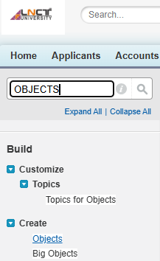
Click on “Address” Object.
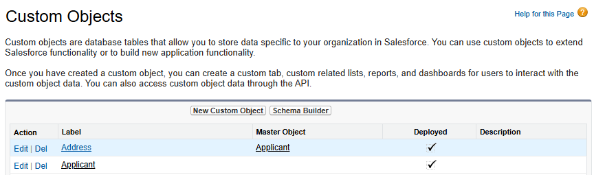
Click on “new” to create field.
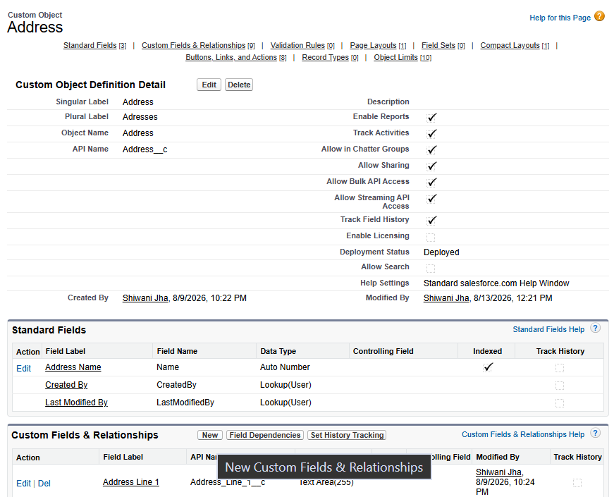
Click New → Formula Field.
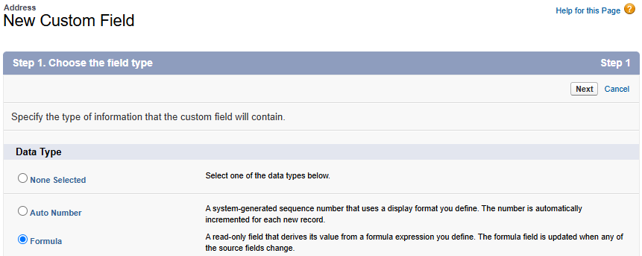
Step 2:
Enter the Field Label:
Applicant Full Name
Select:
Return Type → Text
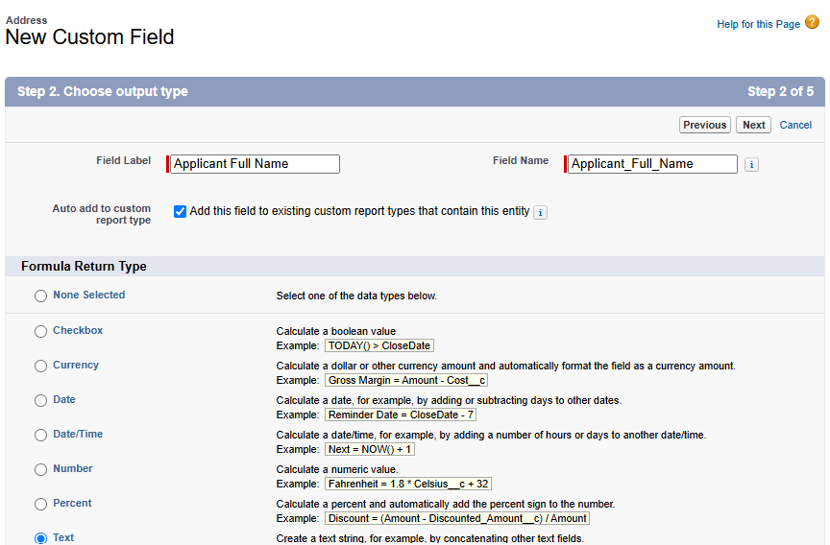
Step 3:
In the Formula Editor:
Address → Applicant Fields → First Name
and
Address → Applicant Fields → Last Name
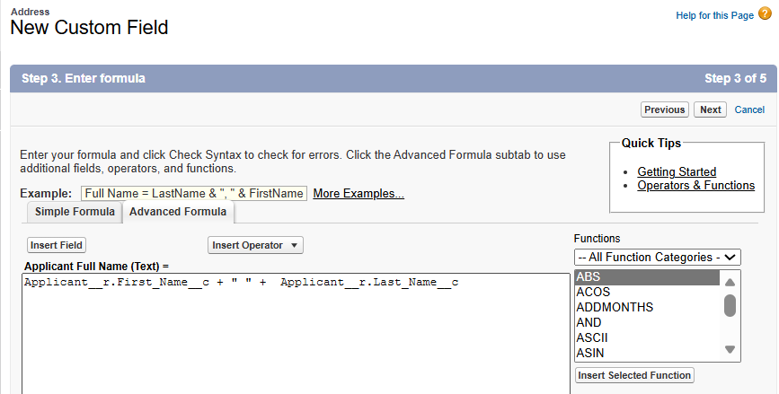
Formula:
Applicant__r.First_Name__c + " " + Applicant__r.Last_Name__c
Step 4:
Click Next → Make Visible to All → Next → Save.
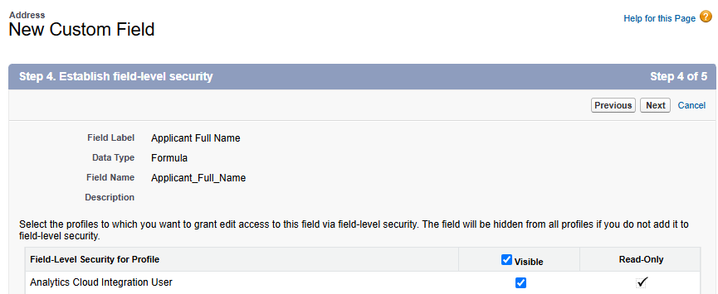
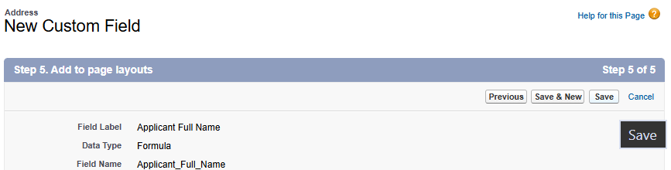
Step 5:
Open an Address record and check the Applicant Full Name field.
The Applicant's first name and last name will be displayed on the Address record.
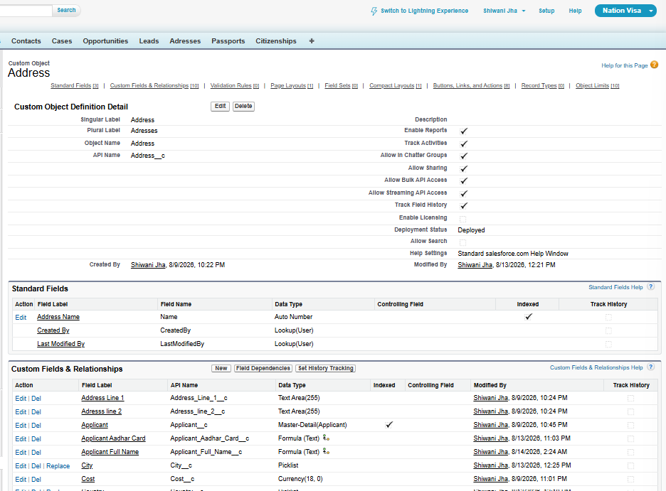

2. Cross Formula Field Using Checkbox
We also created a Formula Field to display the Applicant's PAN Card based on a Police Verification checkbox.
Step 1:
Go to:
Setup → Objects → Address → New → Formula Field
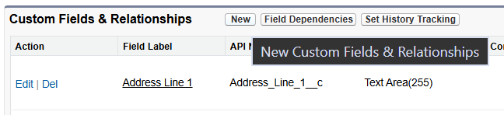
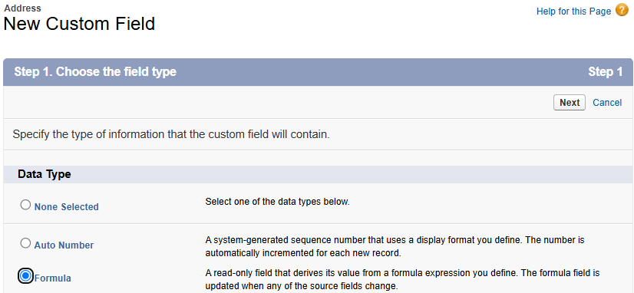
Step 2:
Select:
Return Type → Text
Field Label:
Applicant PAN Card
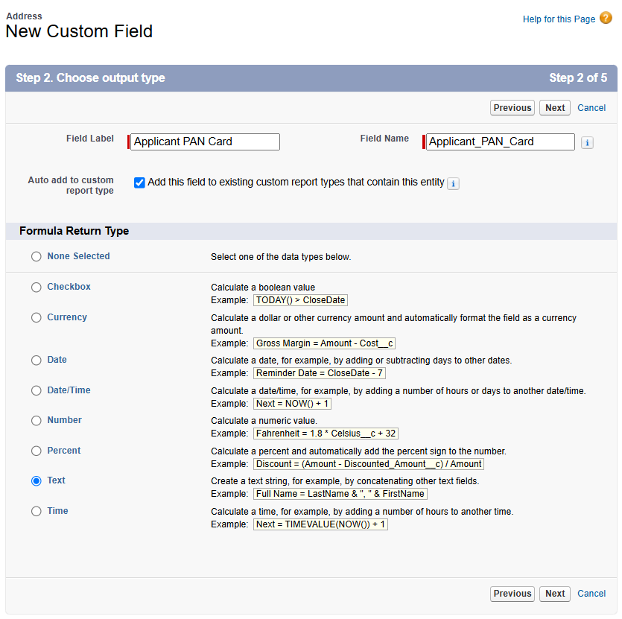
Step 3:
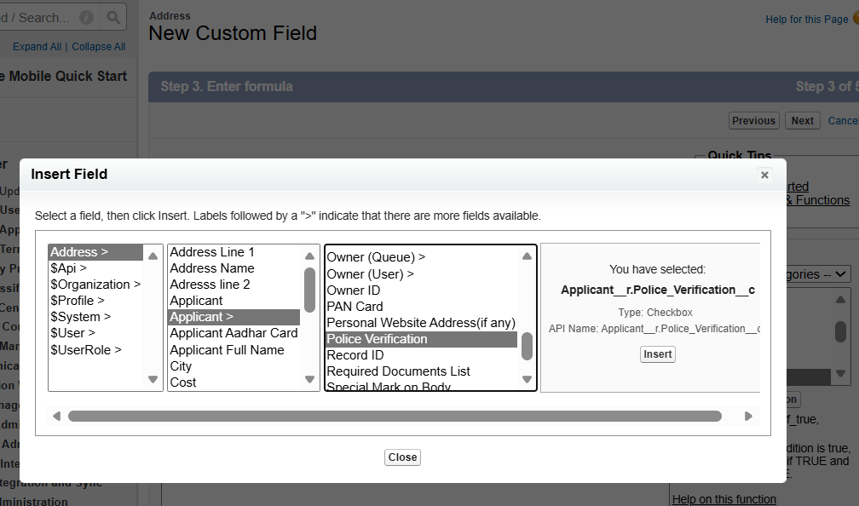
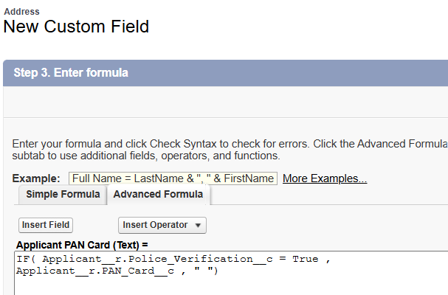

IF( Applicant__r.Police_Verification__c = True , Applicant__r.PAN_Card__c , " ")
Step 4:
Click:
Next → Next → Save
Result-
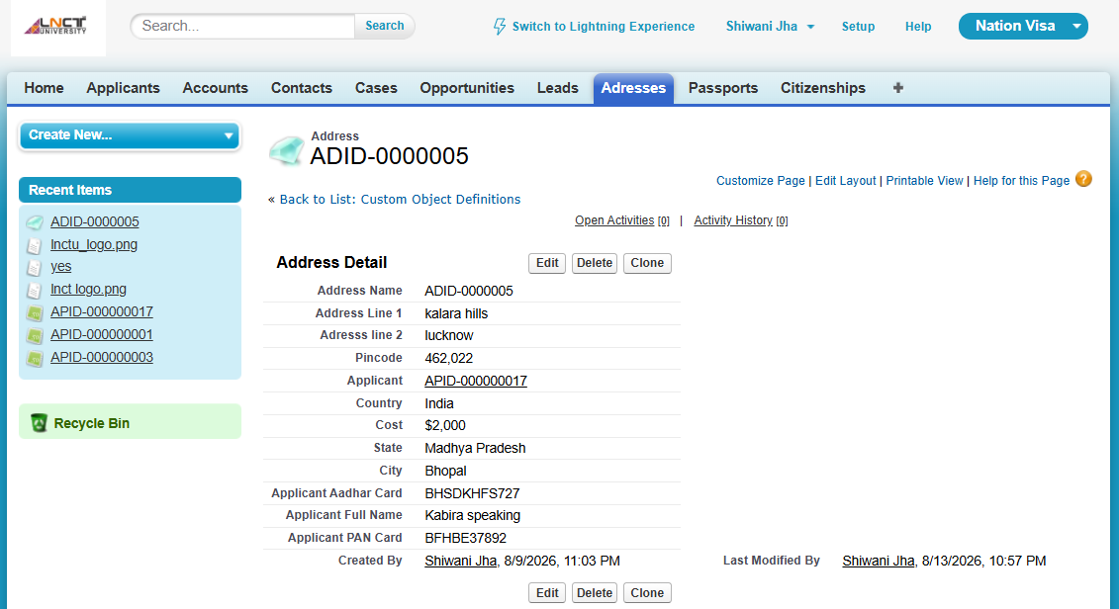
Important
A Checkbox returns either: TRUE OR FALSE.
According to the class notes, the checkbox is True by default.
User Story — Show Applicant's Aadhar Card on Address Object
Requirement
Show the Applicant's Aadhar Reference Number on the Address object only when:
- Applicant's Email ID is not blank.
- Applicant's Gender is Male or Female.
- Applicant's PAN Card starts with "B".
- Address City is Bhopal.
Step 1
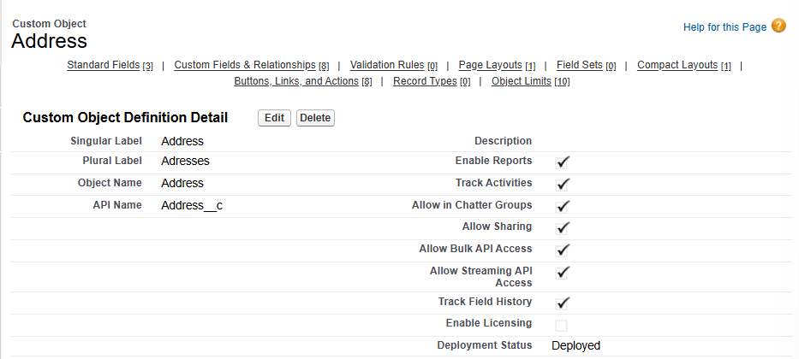
Step 2 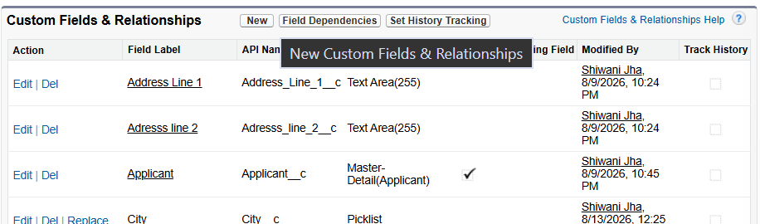
Step 3
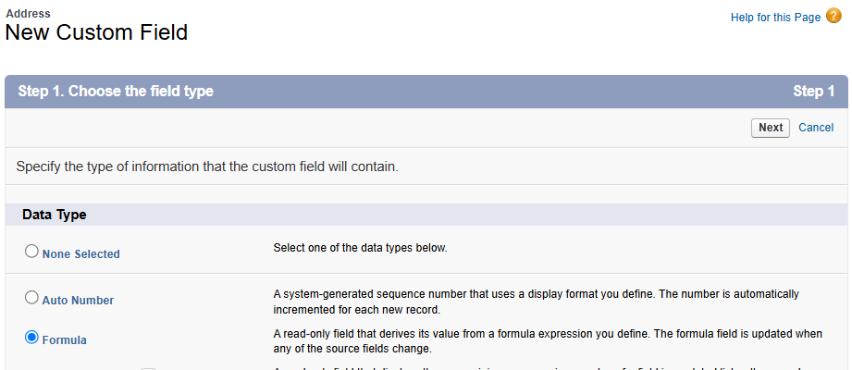
Step 4
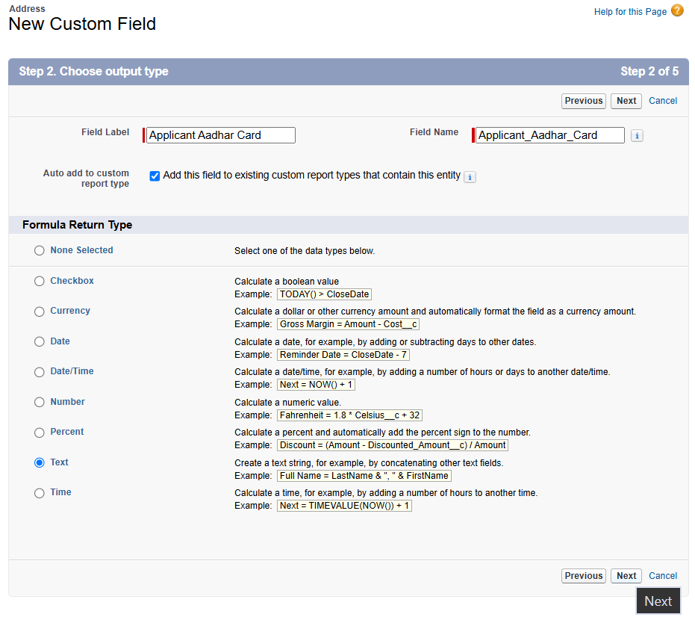
Step 5
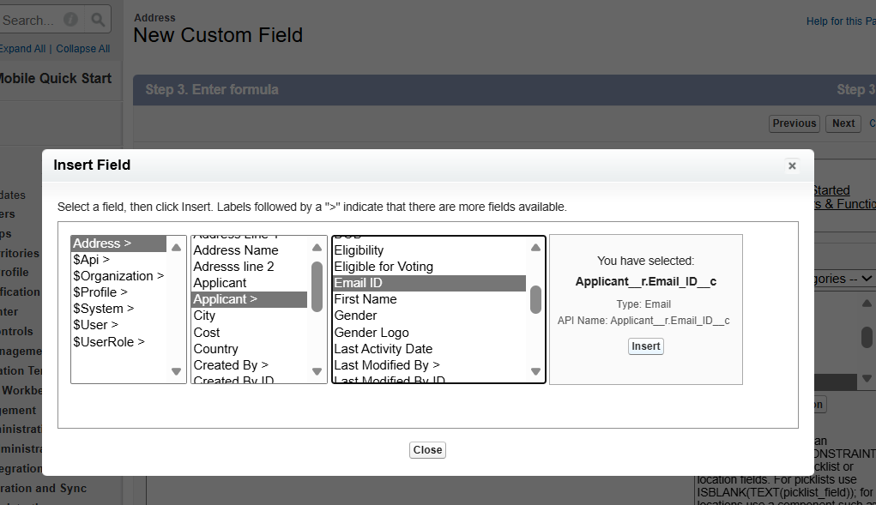
Step 6

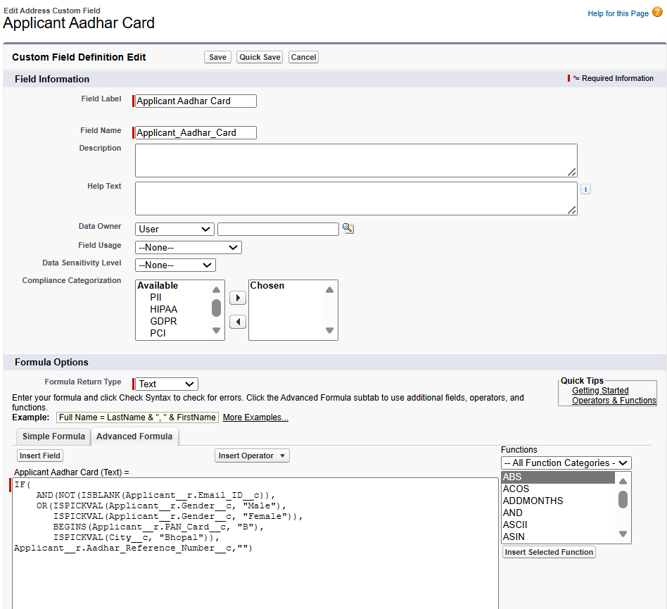
IF(
AND(NOT(ISBLANK(Applicant__r.Email_ID__c)),
OR(ISPICKVAL(Applicant__r.Gender__c, "Male"),
ISPICKVAL(Applicant__r.Gender__c, "Female")),
BEGINS(Applicant__r.PAN_Card__c, "B"),
ISPICKVAL(City__c, "Bhopal")),
Applicant__r.Aadhar_Reference_Number__c,"")

Result –
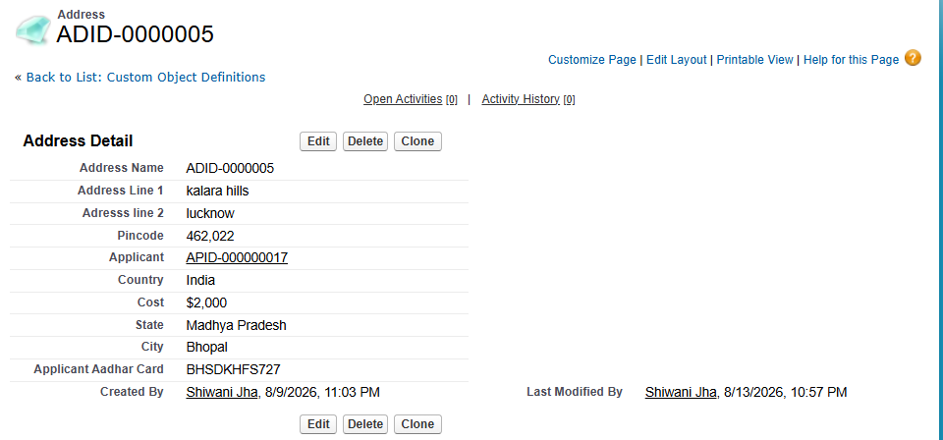

Junction Object
A Junction Object is used to create a Many-to-Many (N:N) relationship.
Example: Applicant Citizenship is the Junction Object.
It has two Master objects:
- Applicant
- Citizenship
Applicant ← Applicant Citizenship → Citizenship
The Applicant Citizenship object acts as the junction between Applicant and Citizenship.
Important Points
- A Junction Object has 2 Master-Detail relationships.
- It is used to create a Many-to-Many relationship.
- One-to-Many relationships are created using a Master-Detail relationship.
Steps
Step 1:
Create the Citizenship object.
# step 1
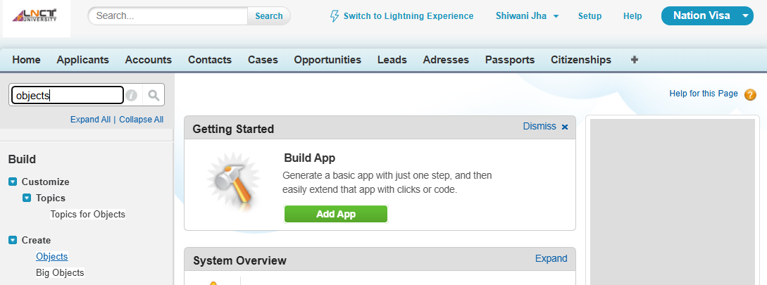
# step 2
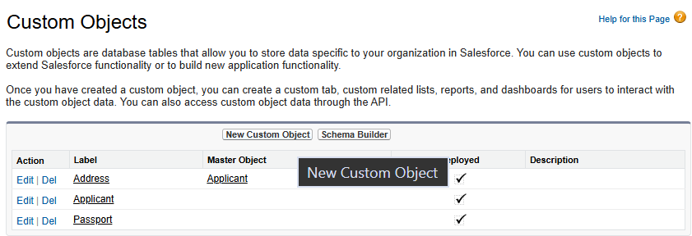
# step 3
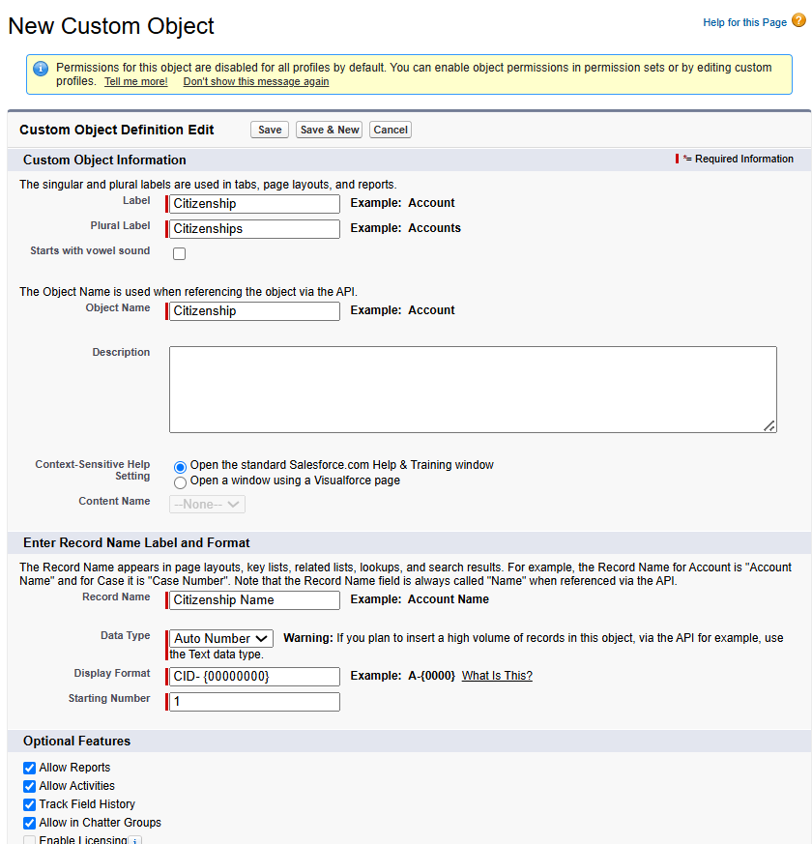
# step 4
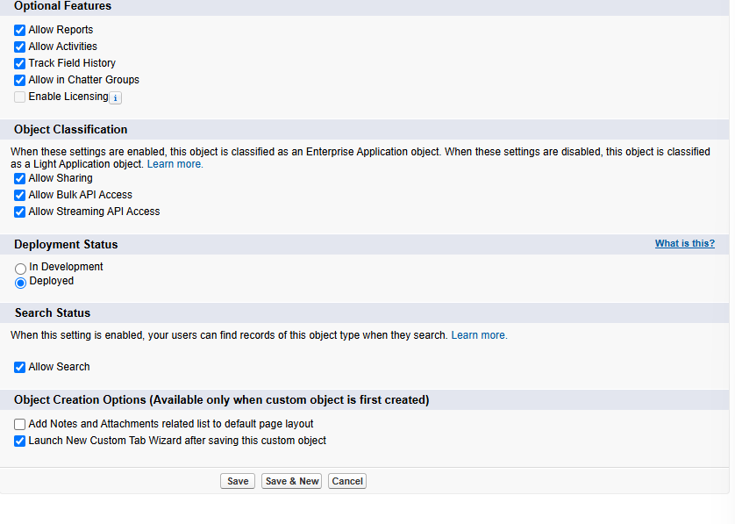
# step 5
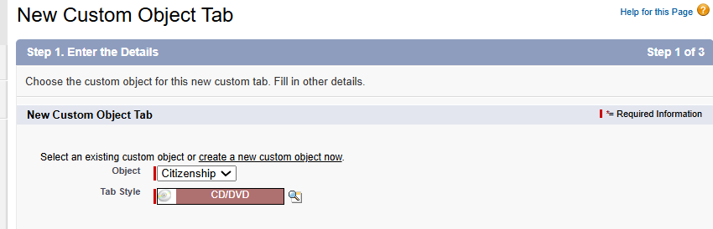
Fields of –
- Basis
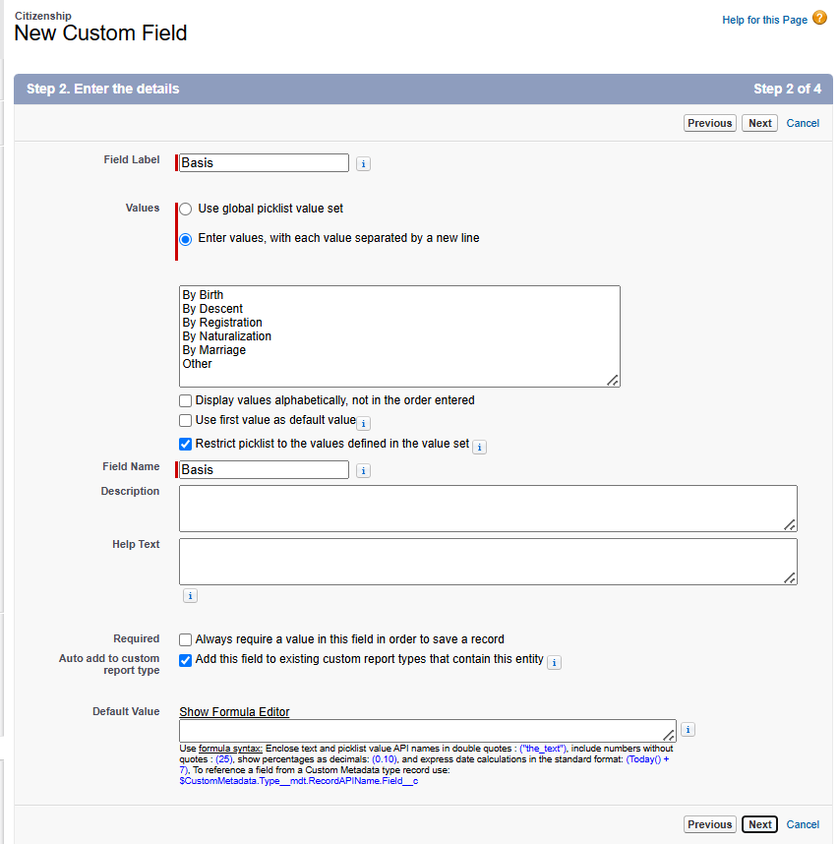
- Dual Citizenship
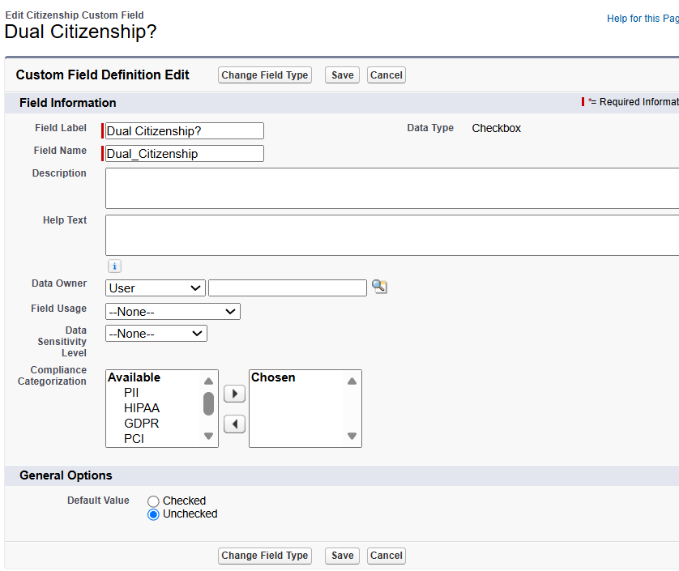
- Nationality
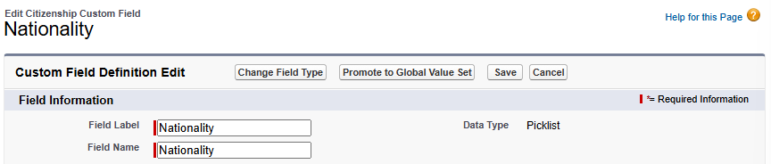
Result-
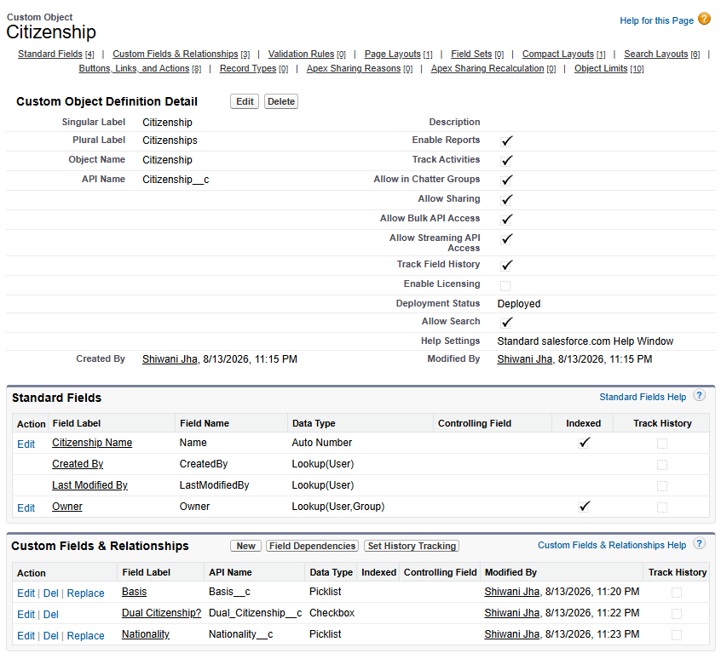
Step 2:
Create the Applicant Citizenship object.
Similarly,
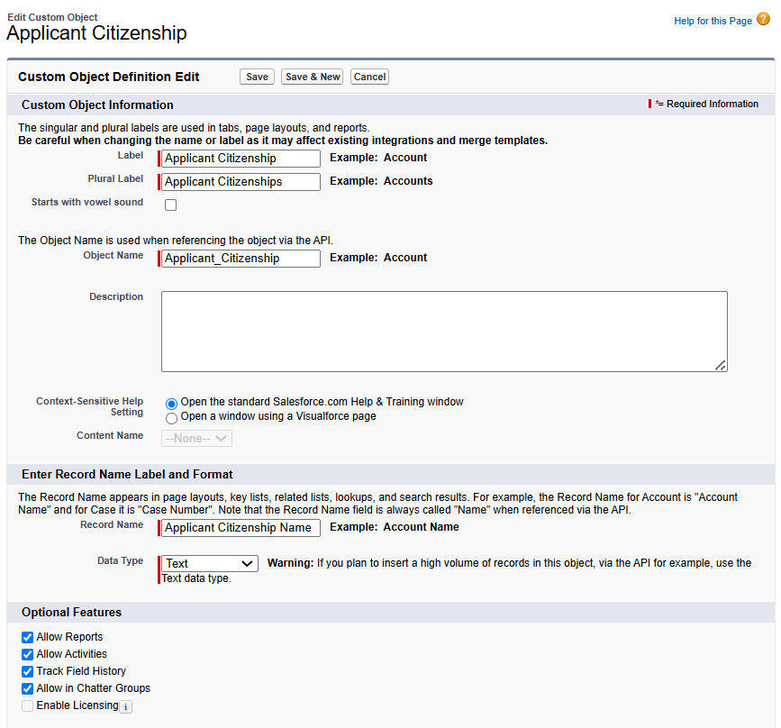
Result-
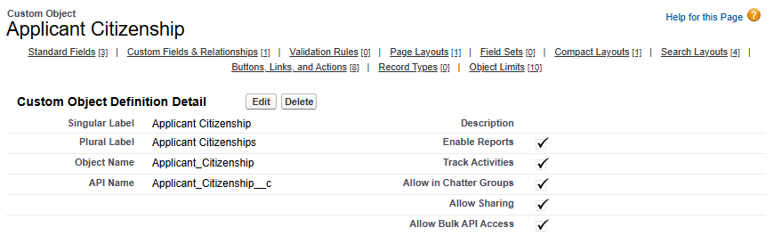

Step 3:
Create a Master-Detail relationship with the Applicant object.
# Step 1
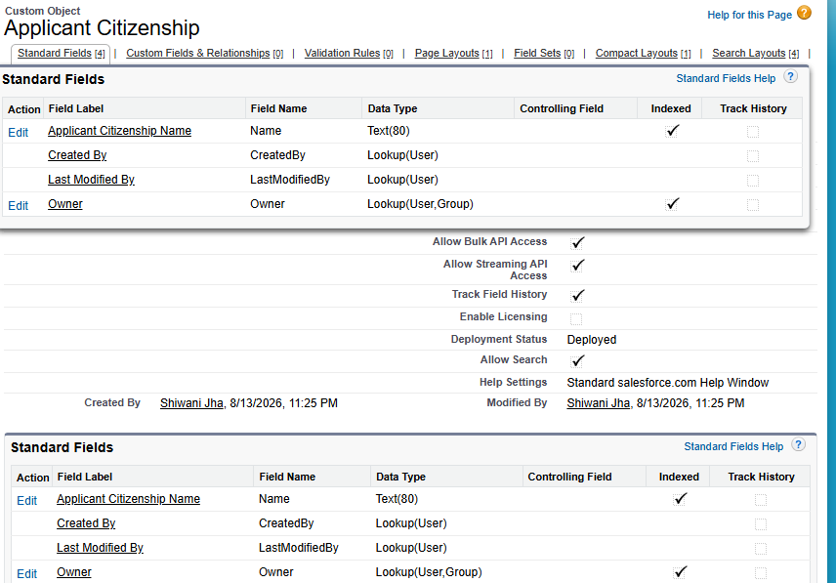
# Step 2
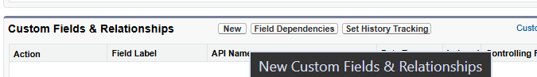
# Step 3
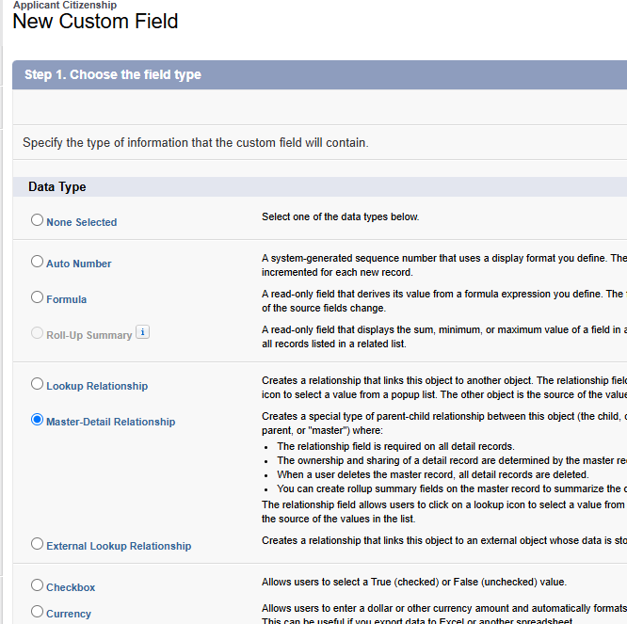
# Step 4
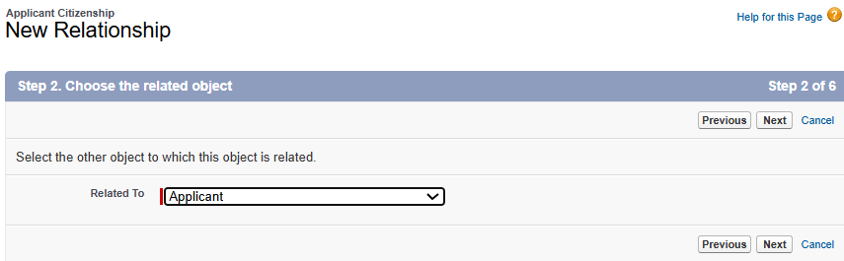
# Step 5
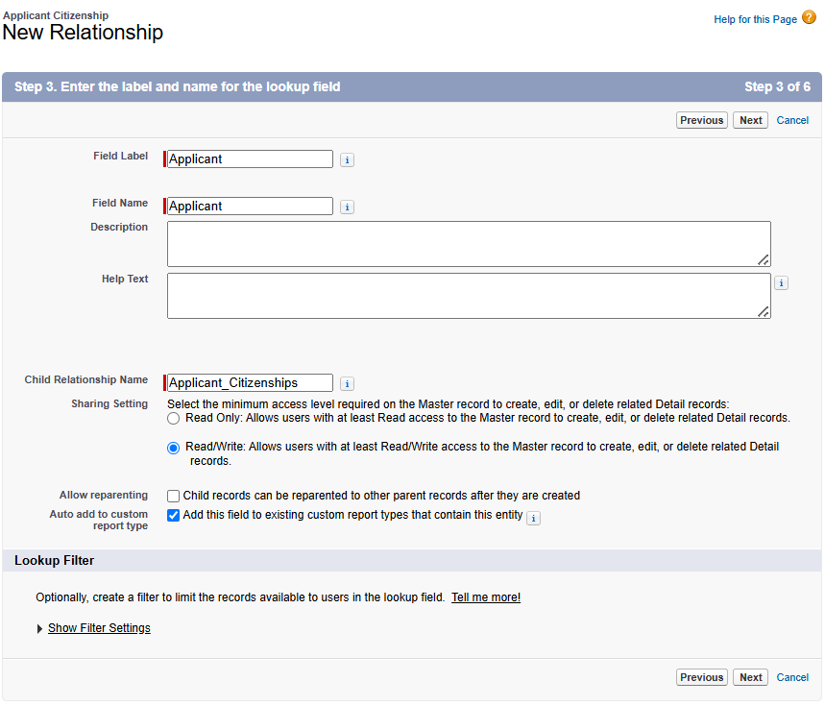
Next -> Next -> Save
Result-
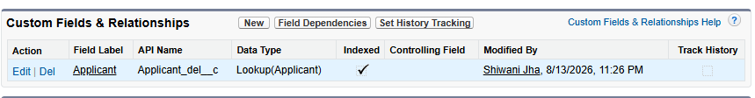

Step 4:
Create another Master-Detail relationship with the Citizenship object.
# Step 1
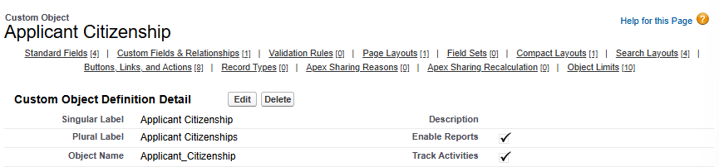
# Step 2
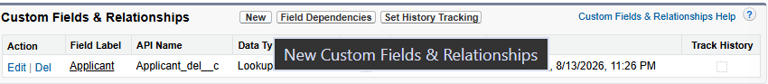
# Step 3
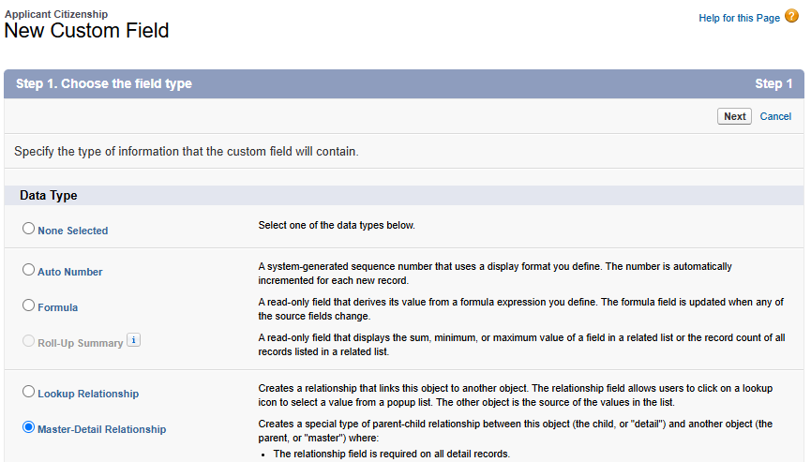
# Step 4
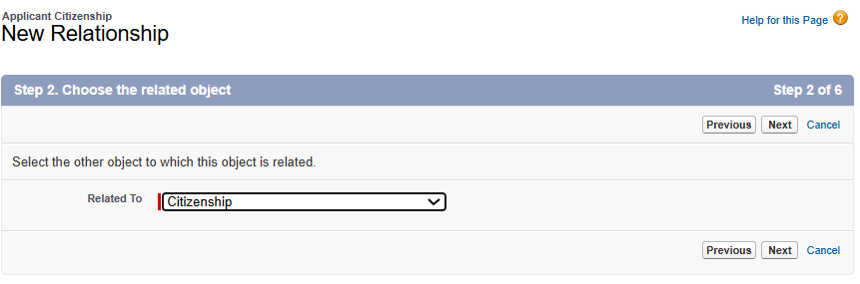
# Step 5
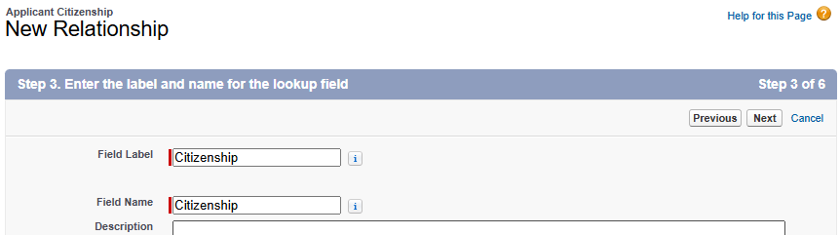Next -> next -> Save.
Result-
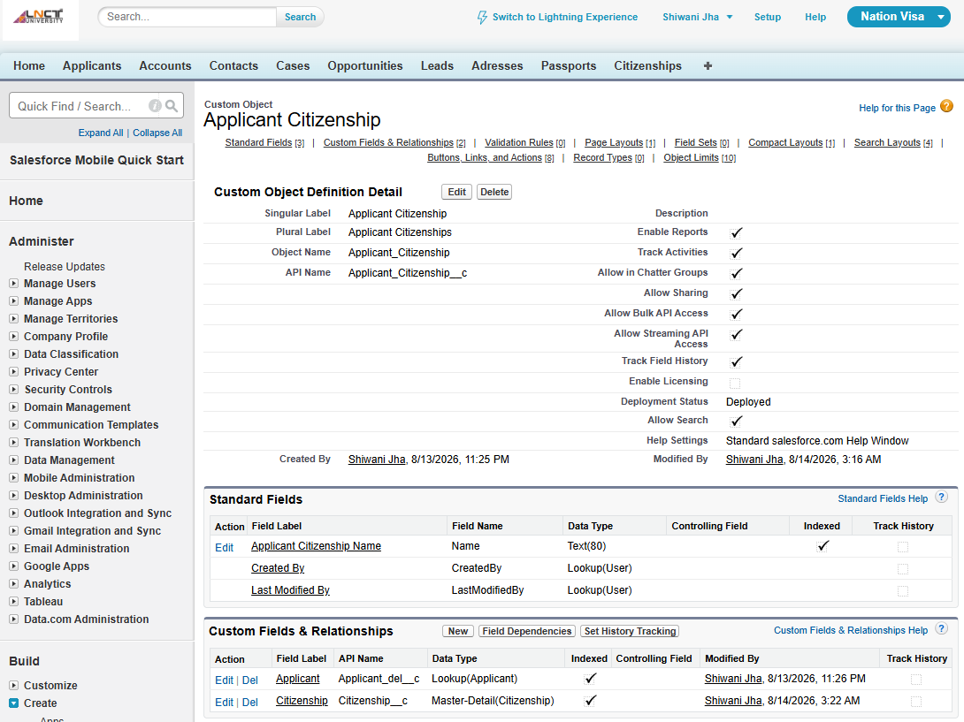
Step 5:
The resulting object is:
Applicant_Citizenship
This becomes the Junction Object.

Maximum Relationships on an Object
Question:
How many relationships can be created on one object?
Maximum = 40 relationships
Minimum = 0 relationships
Distribution
Master-Detail: Maximum 2
Lookup: Maximum 40
Therefore, possible combinations include:
2 Master-Detail + 38 Lookup = 40
1 Master-Detail + 39 Lookup = 40
0 Master-Detail + 40 Lookup = 40
Important Example
The Applicant Citizenship object has:
- 2 Master-Detail relationships
- It is therefore a Junction Object.
- It can have other 38 lookup relationships only.

Homework
- Change the Salesforce logo.
- Change the logo/image that appears during reload/loading.

Solution-
Step 1: Click on this “”
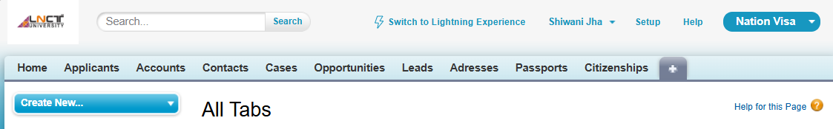
Step 2: Search Document, scroll down in All tabs
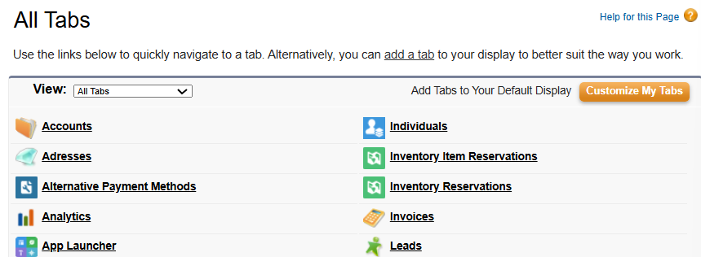
See document-
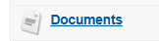
Step 4
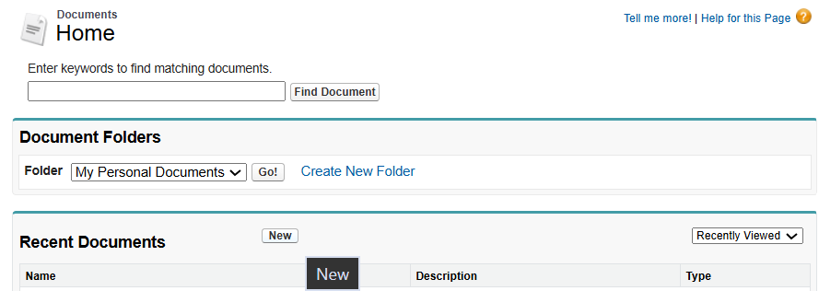
Step 5: Upload the image, and tick on the option “Externally available image”
Click on “Save”.
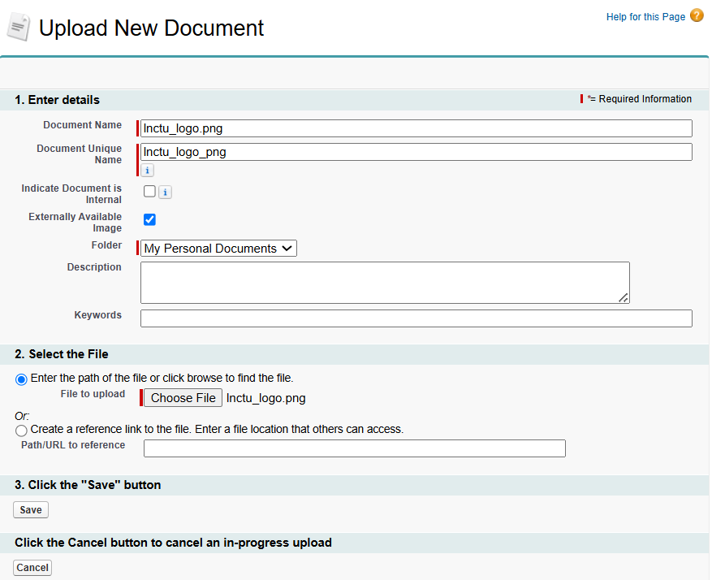
Result-
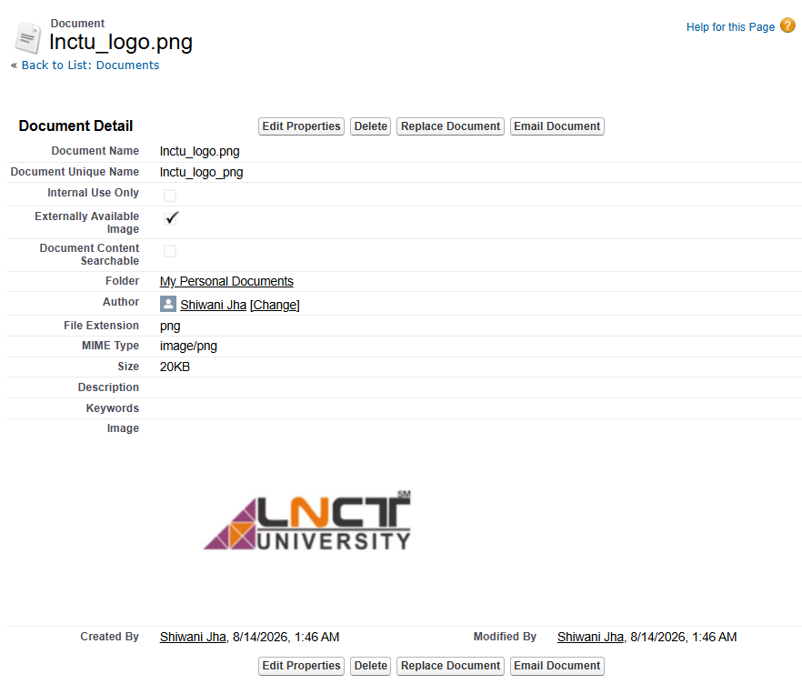
Step 6: click on setup
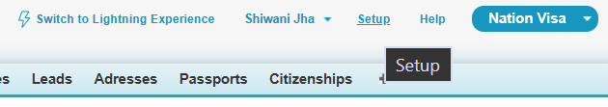
Step 7: Search apps
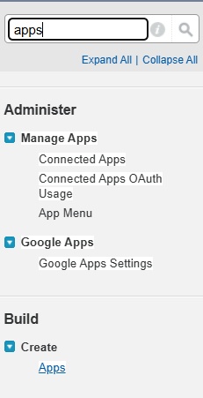
Step 8: Click on “Edit” of Nation Visa
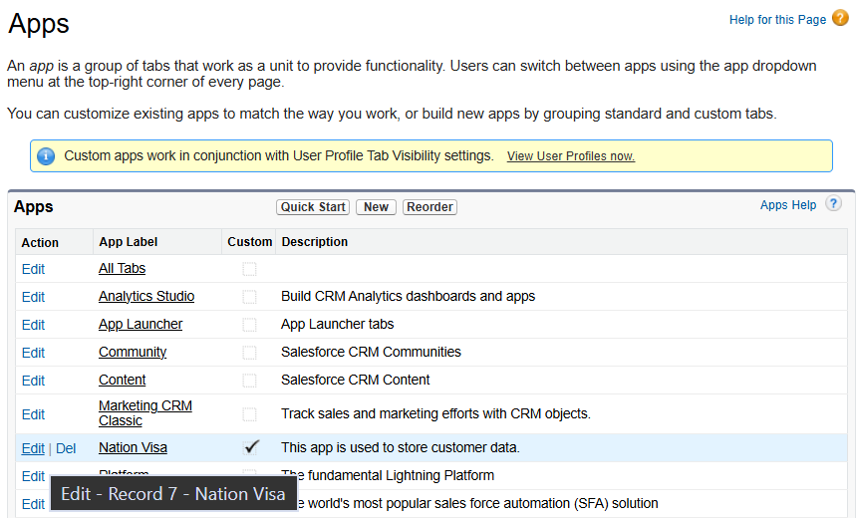
Step 9: Click on “insert image”
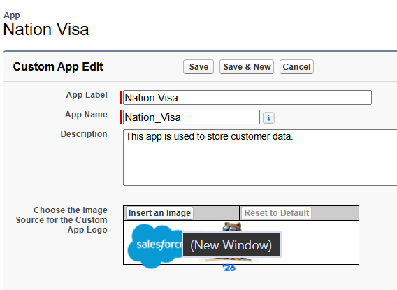
Step 10: Choose the image
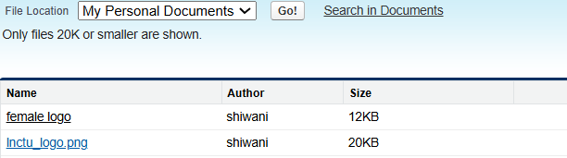
Step 11: Save it
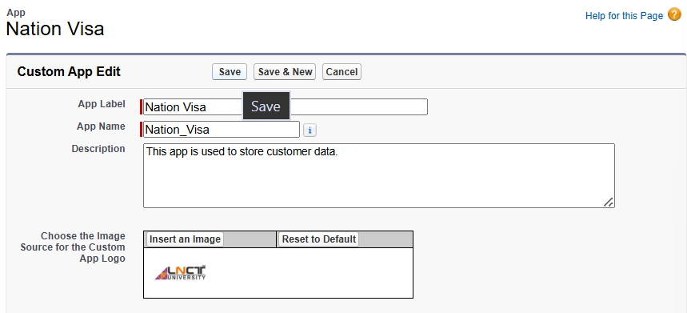
Result-
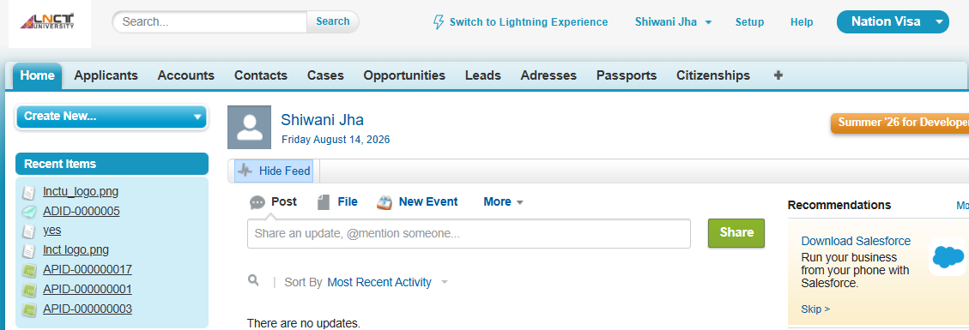
2. Change the Logo During Loading/Reload
This is a different setting from the Classic app logo.
Salesforce provides a Salesforce Branding setting for the loading page logo.
Step 1: Go to -> Setup
Step 2: In Quick Find, search: Branding
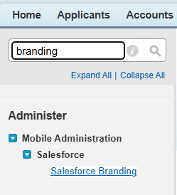
Then select: Salesforce Branding
Step 3: Click -> Edit
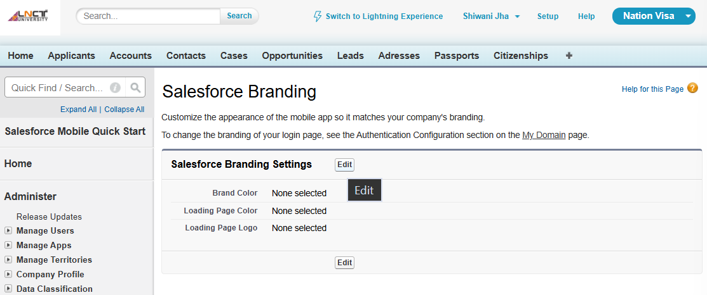
Step 4: Find: Loading Page Logo
Click: Choose File
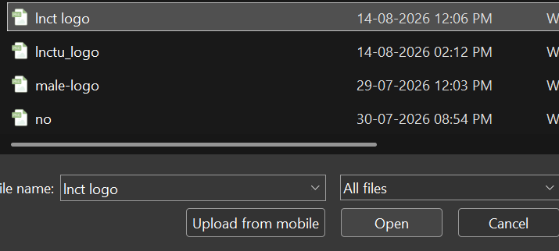

Step 5
Select your logo/image from your computer.
For this loading-page logo, Salesforce currently accepts JPG, GIF, or PNG, up to 200 KB, with a maximum image size of 460 × 560 px.
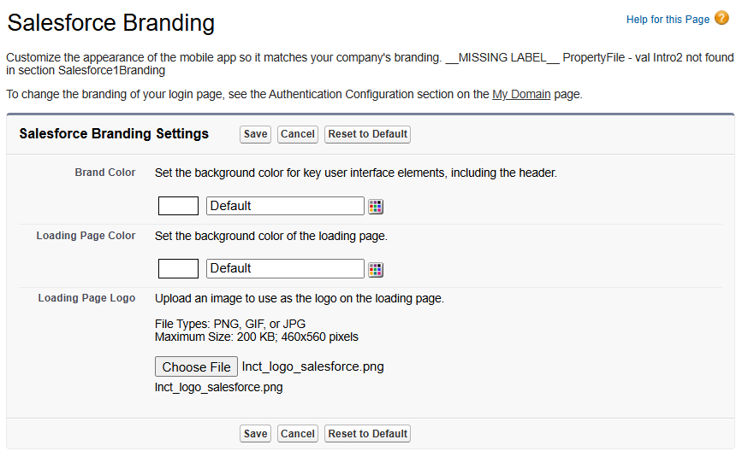
Step 6: Click: Save
Step 7: Now refresh/reload Salesforce and check the loading screen.

